## Reports/ Rx Reports/ Emergency C2 Fills Report

Request:

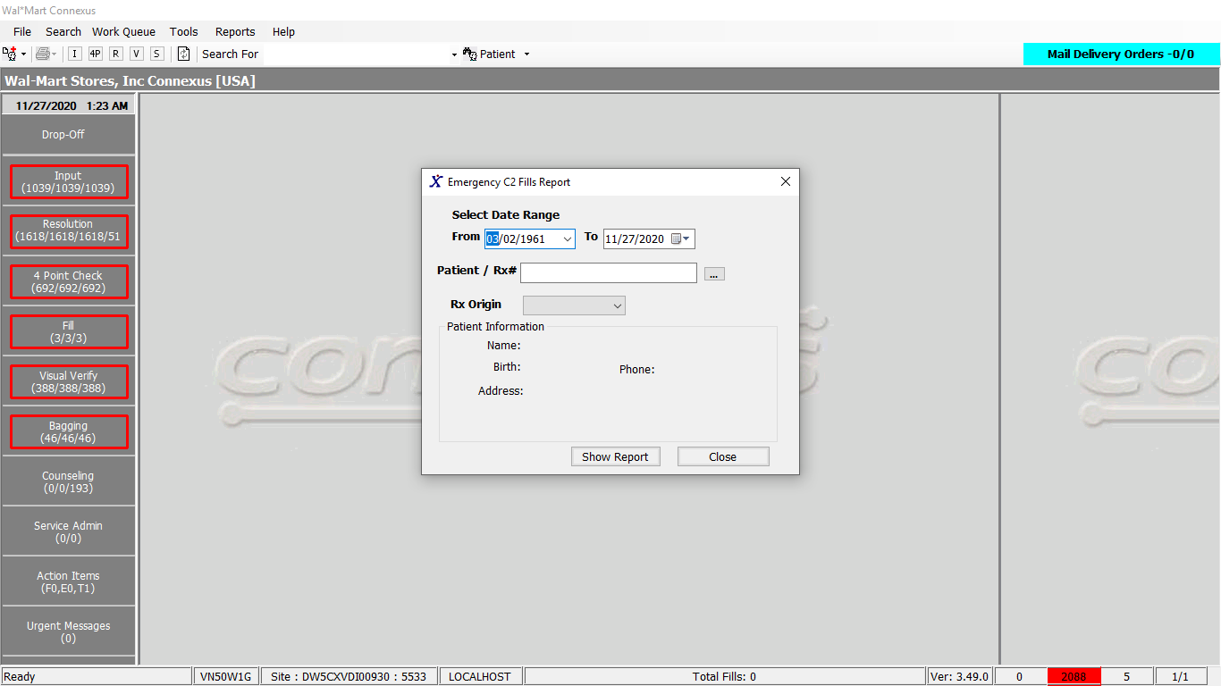

Response:

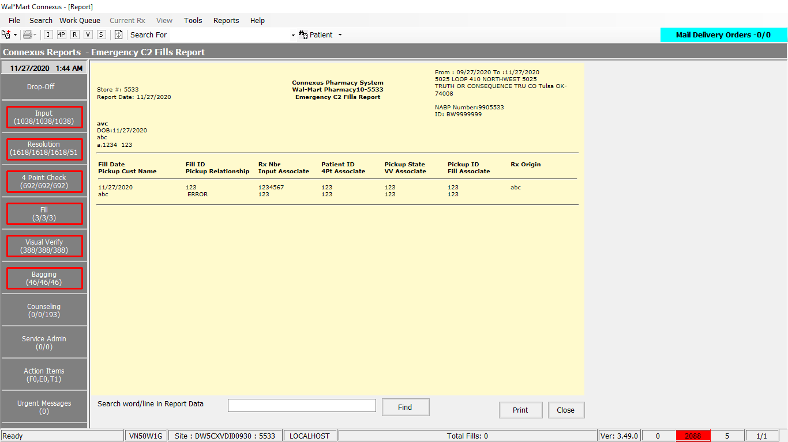

Query:

1. Friend Const GetEmergencyC2Report As String = " select trim(nvl(p.last_name,'')) || ', ' || trim(nvl(p.first_name,''))patientname,p.patient_id,p.birth_date,subjAdd.address_line_1, subjAdd.city_name,subjAdd.state_prov_code,subjAdd.postal_code,rx.rx_nbr,rot.rx_origin_desc,rx.rx_entry_userid, rx.rx_check_userid, rxf.rx_fill_id,rxf.fill_date,rxf.rph_of_rec_userid,rxf.tech_of_rec_userid, rxf.rx_fill_id,rxf.fill_date,rxf.rph_of_rec_userid, rxfp.pickup_state_code,rxfp.pickup_id_nbr,rxfp.pickup_cust_name,rxfp.pickup_rltns_code , rxfp.govt_id_doc_id FROM rx rx,rx_fill rxf, rx_fill_pickup rxfp,patient p,subject_address subjAdd,pharmacy_offering:pharmacy_product prod,rx_origin_text rot WHERE rx.patient_id = p.patient_id AND subjAdd.subject_id = p.patient_id AND rx.rx_id = rxf.rx_id AND rx.product_mds_fam_id = prod.product_mds_fam_id AND rxfp.rx_fill_id = rxf.rx_fill_id AND rx.rx_origin_code= rot.rx_origin_code AND rxf.emergency_fill_ind = 'Y' AND prod.drug_control_code = ? AND p.patient_id = ? " &

" AND subjAdd.subject_type_code = ?"

2. Public Const GetDateTime As String = "Select CURRENT dtmCurrent FROM systables where tabname = 'systables'"

DAL:

Public Function GetEmergencyC2Report(ByVal siteId As Integer, ByVal inputData As EmergencyDataBE) _

As List(Of EmergencyInfoBE) Implements IReportDAL.GetEmergencyC2Report

Using (New Tracer(ConnexusCommonConstants.ConnexusTracer))

Dim sqlString As New StringBuilder

Dim emergencyInfoList As New List(Of EmergencyInfoBE)

sqlString.Append(ReportQueries.GetEmergencyC2Report)

Dim paramList As New List(Of DbParameter)

paramList.Add(ParameterHelper.BuildParameter("DrugControlCode", DbType.Int32, ServicesCommonConstants.DrugControlSch2))

paramList.Add(ParameterHelper.BuildParameter("PatientId", DbType.Int32, inputData.PatientId))

paramList.Add(ParameterHelper.BuildParameter("SubjectTypeCode", DbType.Int32, ServicesCommonConstants.PhyIntPatientSubject))

If inputData.RxOrigin > 0 Then

sqlString.Append(" AND Rx.rx_origin_code = ? ")

paramList.Add(ParameterHelper.BuildParameter("RxOriginCode", DbType.Int32, inputData.RxOrigin))

End If

sqlString.Append(" AND rxf.fill_date IS NOT NULL AND date(rxf.fill_date) BETWEEN ? AND ? ")

paramList.Add(ParameterHelper.BuildParameter("StartSoldDate", DbType.Date, inputData.StartSoldDate))

paramList.Add(ParameterHelper.BuildParameter("EndFillDate", DbType.Date, inputData.EndSoldDate))

Dim dataReader As IDataReader = ExecuteReader(DatabaseEnum.rx21c,

siteId, sqlString.ToString, paramList)

While dataReader.Read

Dim govInfo As GovIdInfoBE

Dim govtId = dataReader.GetValueOrDefault(Of Int32)("govt_id_doc_id")

Dim emergencyInfo As New EmergencyInfoBE

emergencyInfo.RxFillId = dataReader.GetValueOrDefault(Of Int32)("rx_fill_id")

'Gov ID details of pickup person details are captured either in rx_fill_pickup/gov_id_document table.

'When the govid has value it implies pickup person details are captured in gov_id_document table.

If govtId > 0 Then

govInfo = New GovIdInfoBE

govInfo = fillHelper.GetGovtIdDetailsByRxFillId(siteId, emergencyInfo.RxFillId)

emergencyInfo.PickUpIdNbr = govInfo?.IdNbr

emergencyInfo.PickUpCustName = String.Format("{0},{1}", govInfo?.LastName, govInfo?.FirstName)

emergencyInfo.PickUpStateCode = govInfo?.IssueAgencyAbbr

Else

emergencyInfo.PickUpIdNbr = dataReader.GetValueOrDefault(Of String)("pickup_id_nbr").SafeTrim

emergencyInfo.PickUpCustName = dataReader.GetValueOrDefault(Of String)("pickup_cust_name").SafeTrim

emergencyInfo.PickUpStateCode = dataReader.GetValueOrDefault(Of String)("pickup_state_code").SafeTrim

End If

If Not dataReader.IsDBNull(dataReader.GetOrdinal("patientname")) Then

emergencyInfo.PatientName = Convert.ToString(dataReader("patientname"), CultureInfo.InvariantCulture)

End If

If Not dataReader.IsDBNull(dataReader.GetOrdinal("patient_id")) Then

emergencyInfo.PatientId = Convert.ToInt32(dataReader("patient_id"), CultureInfo.InvariantCulture)

End If

If Not dataReader.IsDBNull(dataReader.GetOrdinal("birth_date")) Then

emergencyInfo.BirthDate = Convert.ToDateTime(dataReader("birth_date"), CultureInfo.InvariantCulture)

End If

If Not dataReader.IsDBNull(dataReader.GetOrdinal("address_line_1")) Then

emergencyInfo.AddrLine1 = Convert.ToString(dataReader("address_line_1"), CultureInfo.InvariantCulture)

End If

If Not dataReader.IsDBNull(dataReader.GetOrdinal("city_name")) Then

emergencyInfo.City = Convert.ToString(dataReader("city_name"), CultureInfo.InvariantCulture)

End If

If Not dataReader.IsDBNull(dataReader.GetOrdinal("state_prov_code")) Then

emergencyInfo.StateProvCode = Convert.ToString(dataReader("state_prov_code"), CultureInfo.InvariantCulture)

End If

If Not dataReader.IsDBNull(dataReader.GetOrdinal("postal_code")) Then

emergencyInfo.PostalCode = Convert.ToString(dataReader("postal_code"), CultureInfo.InvariantCulture)

End If

If Not dataReader.IsDBNull(dataReader.GetOrdinal("rx_nbr")) Then

emergencyInfo.RxNumber = Convert.ToInt32(dataReader("rx_nbr"), CultureInfo.InvariantCulture)

End If

If Not dataReader.IsDBNull(dataReader.GetOrdinal("rx_origin_desc")) Then

emergencyInfo.RxOriginDesc = Convert.ToString(dataReader("rx_origin_desc"), CultureInfo.InvariantCulture)

End If

If Not dataReader.IsDBNull(dataReader.GetOrdinal("rx_entry_userid")) Then

emergencyInfo.RxEntryUserId = Convert.ToString(dataReader("rx_entry_userid"), CultureInfo.InvariantCulture)

End If

If Not dataReader.IsDBNull(dataReader.GetOrdinal("rx_check_userid")) Then

emergencyInfo.RxCheckUserId = Convert.ToString(dataReader("rx_check_userid"), CultureInfo.InvariantCulture)

End If

If Not dataReader.IsDBNull(dataReader.GetOrdinal("fill_date")) Then

emergencyInfo.FillDate = Convert.ToDateTime(dataReader("fill_date"), CultureInfo.InvariantCulture)

End If

If Not dataReader.IsDBNull(dataReader.GetOrdinal("rph_of_rec_userid")) Then

emergencyInfo.RphUserId = Convert.ToString(dataReader("rph_of_rec_userid"), CultureInfo.InvariantCulture)

End If

If Not dataReader.IsDBNull(dataReader.GetOrdinal("tech_of_rec_userid")) Then

emergencyInfo.TechUserId = Convert.ToString(dataReader("tech_of_rec_userid"), CultureInfo.InvariantCulture)

End If

If Not dataReader.IsDBNull(dataReader.GetOrdinal("pickup_rltns_code")) Then

emergencyInfo.PickUpRltnsCode = Convert.ToInt32(dataReader("pickup_rltns_code"), CultureInfo.InvariantCulture)

End If

emergencyInfoList.Add(emergencyInfo)

End While

If emergencyInfoList.Count = 0 Then

Return Nothing

Else

Return emergencyInfoList

End If

End Using

End Function

-------------------------------------------------------------

''' <remarks></remarks>

Public Shared ReadOnly Property GetDBDateTime(ByVal siteId As Integer) As DateTime

Get

Using (New Tracer(ConnexusCommonConstants.ConnexusTracer))

Dim dbDateTime As DateTime

Dim offset As TimeSpan

Dim isOffsetValid As Boolean

'Get the offset time from cache

isOffsetValid = TimeSpan.TryParse(Convert.ToString(CnxCache(CStr(CacheKeys.OffsetTime))), offset)

If (Not isOffsetValid) Then

'get it from db

'execute query

dbDateTime = CDate(ExecuteScalar(DatabaseEnum.rx21c, siteId, BaseQueries.GetDateTime))

offset = dbDateTime.Subtract(DateTime.Now)

'Add it to Cache

CnxCache.Add(CStr(CacheKeys.OffsetTime), offset, CacheHelper.GetExpirationPolicy(CStr(CacheKeys.OffsetTime)))

End If

Return DateTime.Now.Add(offset)

End Using

End Get

End Property